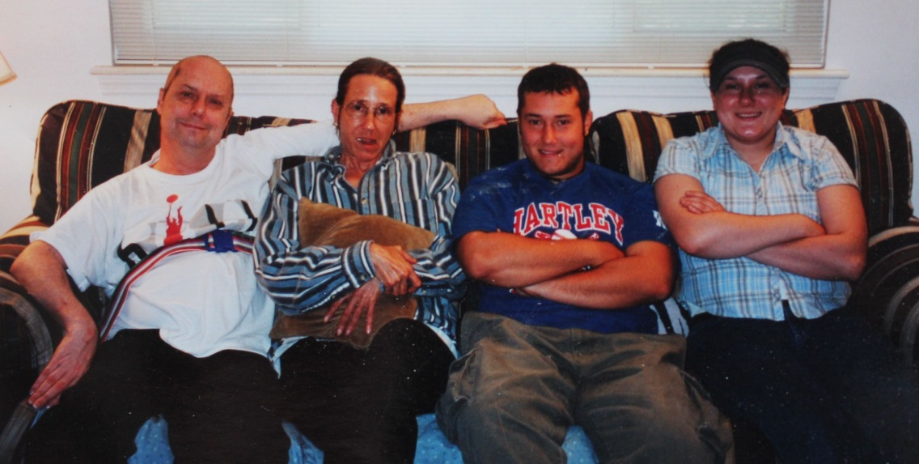

(l-r) Greg Markel, Susan List Markel, David and Vallery Markel – 2001

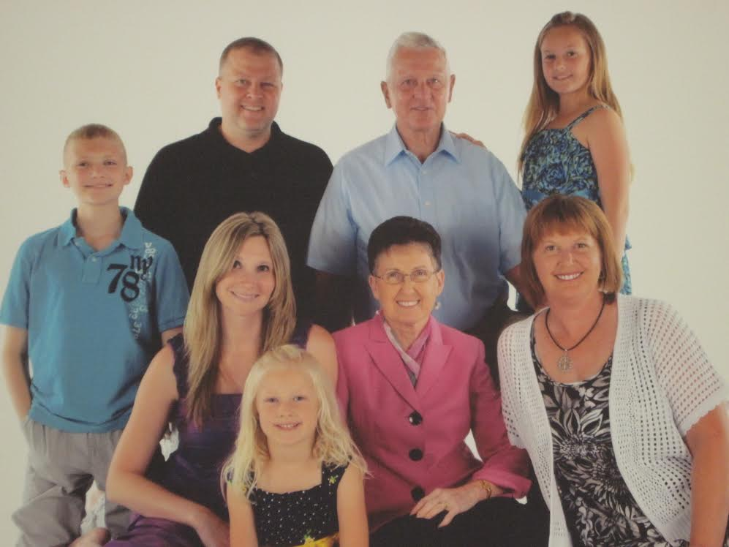

**Mark & Jeanette List Family: June 2012**

**Back Row: Maverick, Roger, Mark, and Joselin**

**Front Row: Jennifer, Marin, Jeanette, and Dawn**